#fvwp  NEWSLETTER |  | 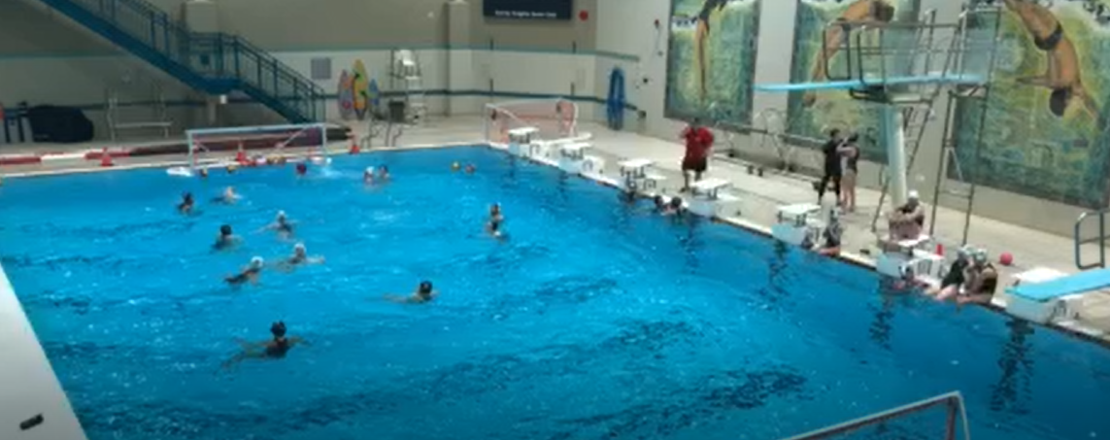

INSIDE
THIS
ISSUE
PG. 2  Strategies of FVWPC for 2018/2019  PG. 3  Player Highlights  PG. 4  Important Dates to Remember  PG. 5  Final Word from Executive |  |  |  | Newsletter name  subtitle  We are so excited for the upcoming season, Michel Roy is leading our new coaching staff and I know our athletes are eager to get in the pool and play.

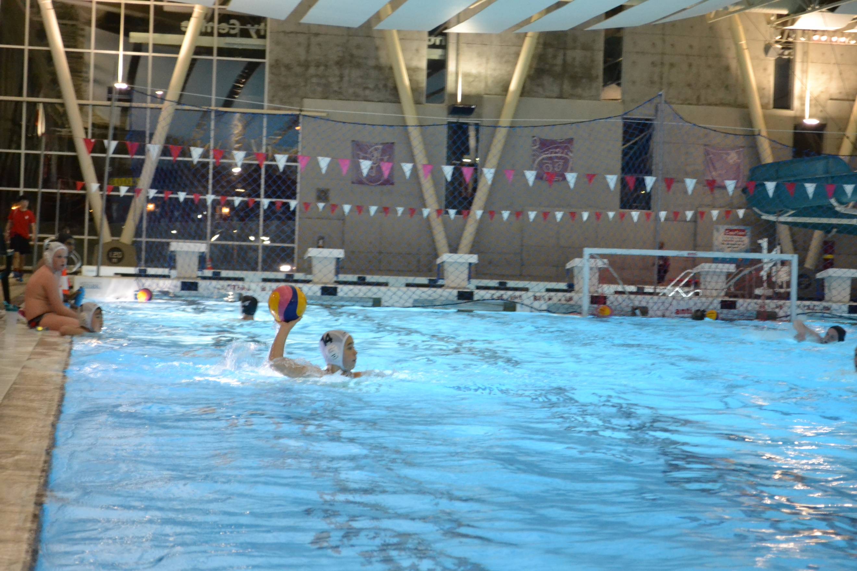 |  |  | Strategies for FVWPC  - Grow the Club and athletes  - Improve our communication with the membership & improve our transparency  - Continue to develop a PSO program with BC Water Polo Clubs  - Invest in our coaches with new equipment, video software and blah blah blah

Player highlights

Maddalena Vidale
School: International student at EMS
Where are you from: Italy
How long have you been playing water polo: since I was 6
Position: utility
Spare time:

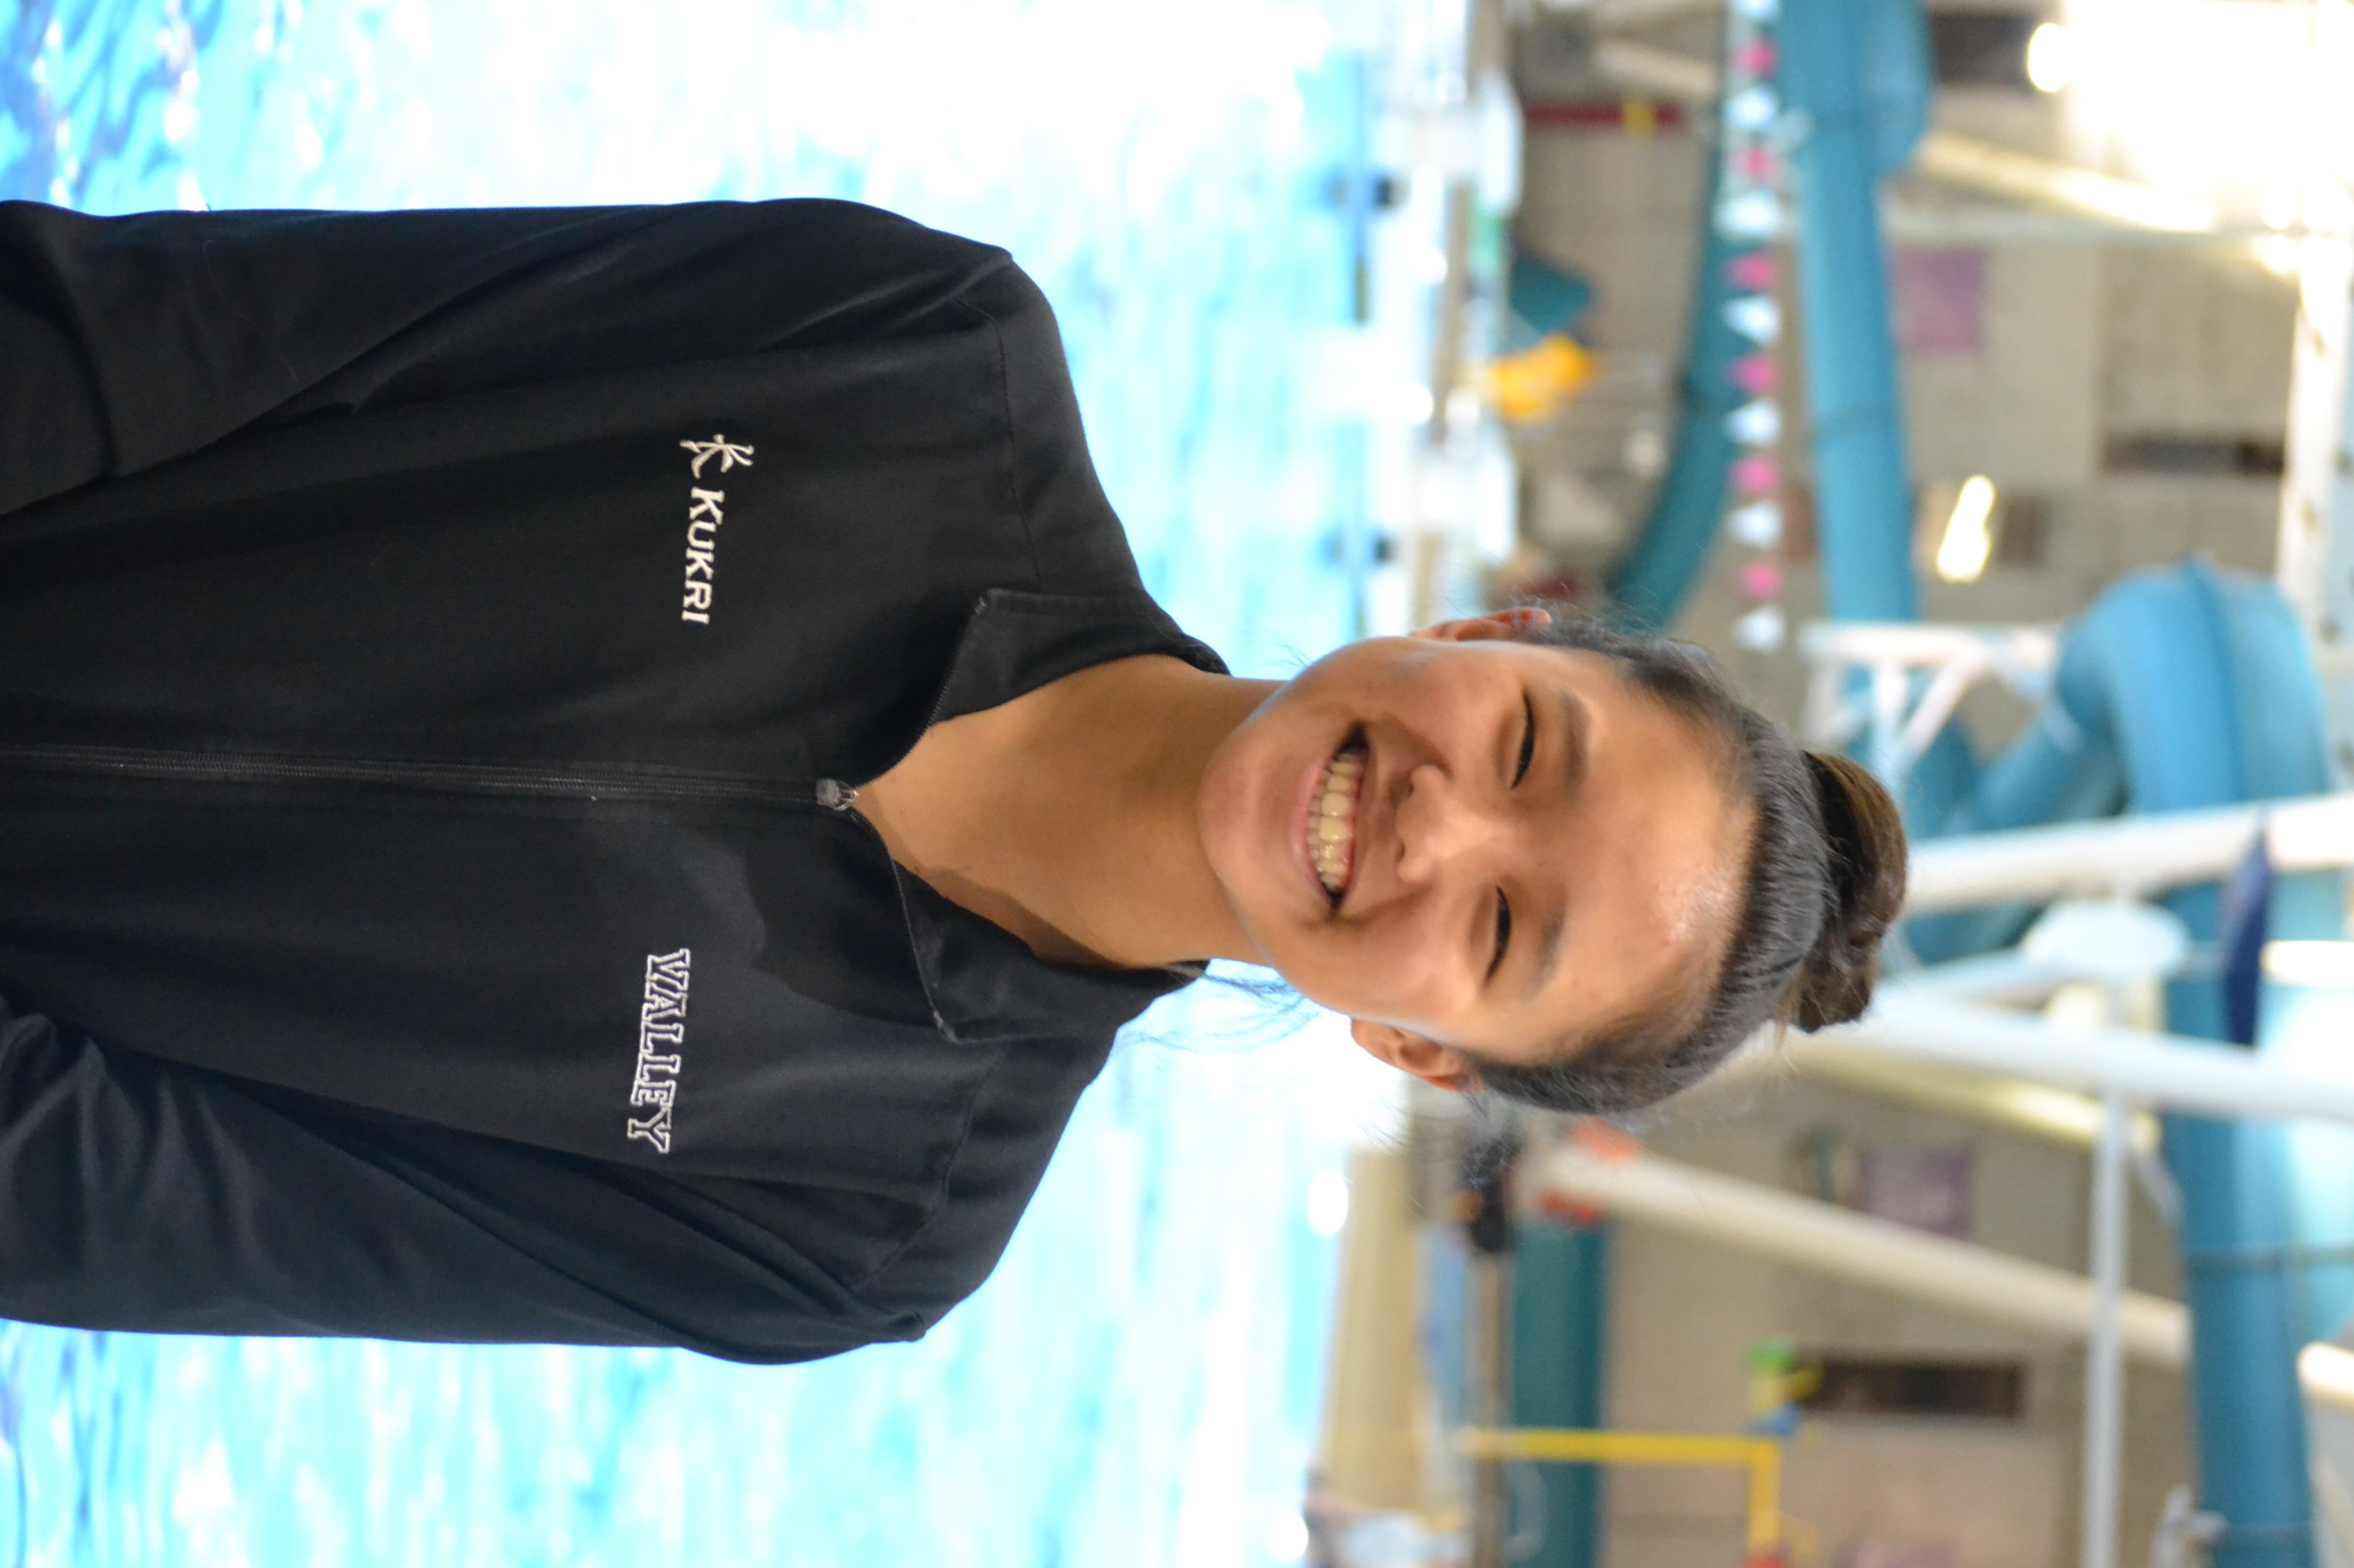 Player highlights

Sarah joins us from the Valley
Fav food: pasta, ice cream
How long have you been playing water polo: this is my 6th year
Position: driver
Goals: make nationals
Spare time: spend time with my family, friends, dog, listening to music, write, read

Calgary additions x 2

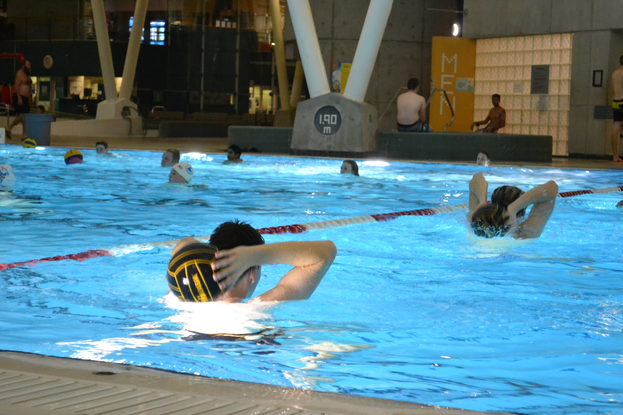 |  |  | Important dates to remember  Pool closures over the holidays  spring break trip to california  Pool closures over the holidays  spring break trip to california

Final Comment

executive update
To change any of the text in this document, just click on the block of text you want to update! The formatting has already been programmed for ease of formatting.
You can easily change the overall colors of the template with just a few clicks. Go to the Design tab and click on Colors. From the list of colors, you can choose a different color scheme. As you hover over the different choices, you can see what the overall feel of the document will change with each different option.
Changed the color and want to go back to the original design? Easy! Just go back to the Design tab and choose the Themes option. From the list, click the option to reset the theme of this template. And just like that, your document color scheme will be restored to its original!
Have other images you wish to use? It is simple to replace any of the pictures in this newsletter. Click twice on the image you wish to change. Some images may need an extra click as they are part a group of images. Keep clicking until your selection handles are around the one image you wish to replace.
Once the image you wish to replace is selected, you can either select “Change Picture” from the short cut menu, or click on the “Fill” option and choose the option for “Picture.”
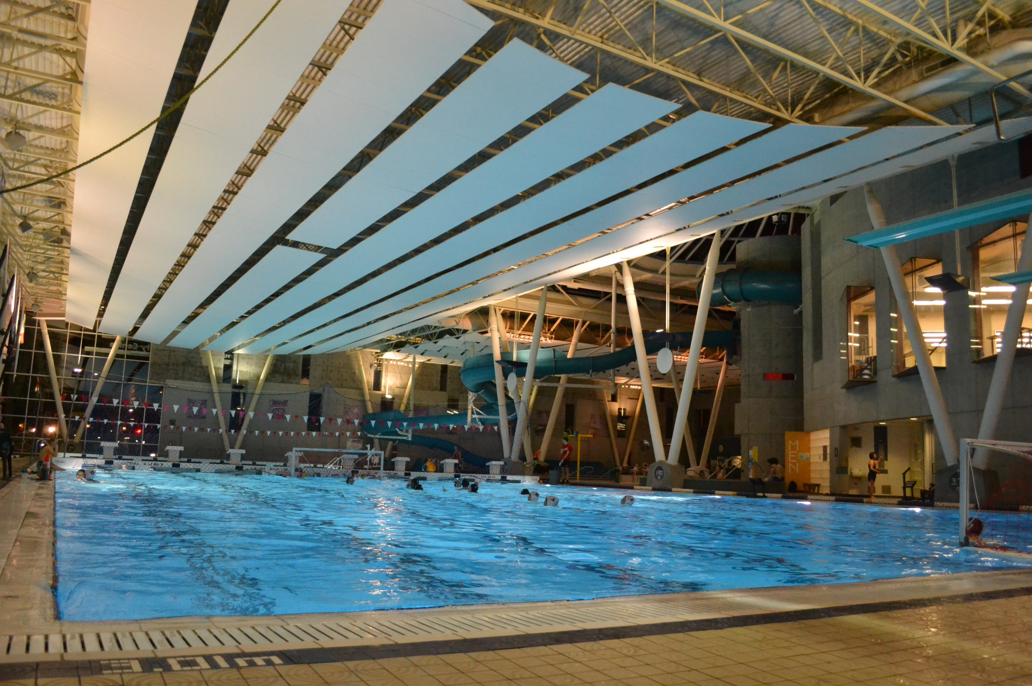

Water Polo canada Update

doug maclaren

